Valentina Stoma

DATA5020 Collect/Store/Retrieve Data Sec 01

Fall 2019

Professor: Sara Arunagiri

***Purpose of the Project***

For the purpose of this project, I chose to focus on examining the National Parks in the US for convenient general purpose use. National parks in the US are some of the most visited natural attractions not only in the US but for the rest the world as well (Western U.S. National Parks Popular with Foreign Tourists). Thousands of people from all over the world visit the US every year to hike up the famous mountains, see the Grand Canyon, and visit the oldest National Park in the US – Yellowstone National Park, established 18972 (Wee).The popularity of many locations all over the country bring tourism to the states that would not normally attract the same number of tourists. Based on this interest in the US National Parks, the project is focused on developing a comprehensive database with the list of National Parks in the US visited by Americans and international tourists. Some of the information that could be useful for trip planning purposes includes the list of National parks, state location, date it was established, and the acres size of the park. Additionally, I am interested in the minimal elevation level, as well as the vertical relief (the change in elevation that occurs from the ground level to the peak). Apart from the statistical information regarding the elevation levels, I am interested in the Mountain range and the Peak that is the official highest elevation for that mountain range.

In addition to described general information for every national park, the report covers a number of trails – assessing the difficulty of them and providing a succinct classification – for some of the oldest and most visited parks. For the purpose of this information to be useful for the tourists outside of the US, I cover three of some of the most internationally visited National Parks – Yellowstone, Yosemite, and Olympic (Western U.S. National Parks Popular with Foreign Tourists). For Yosemite, the project includes an accident report in order to provide a template for future reports. Currently, this is not a normal practice to keep track of all accidents for every national park, therefore, this modification can be applied for the future database. At the moment, news can be accessed for every national park on the curated list, however, I am not including this data in the following database as it is not updated regularly for all the parks on the list (News Releases (U.S. National Park Service)).

Level above general visiting plans, this project is interested in obtaining, keeping, and tracking information about yearly recreational visitors to National Parks, natural protected areas, and natural historic sites in the US. That dataset is obtained from the National Park Service Visitor User Statistics (National Parks Service) - a great resource for reported data for different types of visitations that are recorded at the parks. For this project, the databased contains only recreational visits. Data is obtained for the ten year period from 2009 until 2018, inclusive. This dataset covers many more natural and historic sites, compared to the easily publicly available Natural Park list.

This project connects two previously disconnected parts of data from National Park Services and publicly available sources. This database allows to perform basic analysis of travel trends, as well as general planning by general population. All local files, written reports, and generated pdfs can be accessed at <https://github.com/valentinastoma/DATA5020/>.

***Collection of Data and Implementation***

Problems that can be addressed with this data include assessing national park trip planning based on the location, popularity (visitor number), and trail information of the national parks in the US. Additionally, trends in national park visitations can be estimated. At the moment, changes in visitor number of the popular national parks over the last 10 years can be demonstrated. Additionally, since there is a lot of open-source information about the dates that the parks were established or visitor number, some sources can have discrepancies. Utilizing alternative sources and verified National Park Service information, the database can provide a demonstration of inconsistencies and misreported data. Moreover, utilizing obtained data, the report visualizes the peak height information (Appendix, Image 3). Additionally, trends in visitations to different National Parks can be visualized – attached are examples of individual and combined visualization that can be performed on the obtained data. (Appendix, Image 14,15). This data can be well visualized spacially, example is attached in Appendix A, Image 16.

***Methods:***

Data for this project was obtained from a number of different open sources. First, as one of the goals of this database is to assists in National Park trip planning, I use Wikipedia as a popular first source for general public (List of National Parks of the United States.). The list is succinct and contains only National Park data, in comparison to other sources that combine historic sites, reservoirs, and other types of locations that fall under National Park Service. I combined multiple ways of obtaining publicly available data, depending on which was the most efficient for the layout of the website. For Wikipedia list, I extracted data using Import.io (Web Data Integration – Import.io - Data Extraction, Web Data Harvesting, Data Preparation, Data Integration). Image of who the not cleaned up data looks uploaded into R is attached in the Appendix (Image 1). Upon cleaning up the data, I obtain a dataframe (clean_parks) that can be uploaded to the database (Image 2). Additionally, I create a copy of the clean_parks dataframe, which contains a column with abbreviations of State names, which can be used for graph generation.

Another dataset, which contains 10 most visited parks was extracted from publicly available data on National Park Service website (Visitation Numbers (U.S. National Park Service)). This website data was used to compare to the National Park Service Full report for all historic, reservoir, park, and other location visitations over the last 10 years. This dataset was obtained utilizing R package **rvest** and cleaned up using **dplyr** and **stringr**. Cleaned up dataset sample is attached in Appendix (Image 4)

Next dataset is included in this project with the goal to demonstrate the absence of comprehensive accessible accident report for all the National Parks in the US. This dataset is a report of accidents in Yosemite National Park from 2012 till 2018 (Search and Rescue: Lessons from the Field). Image of the dataset is attached in Appendix (Image 5) . This dataset does not satisfy the requirement to be included into the database because of absence of unique identifier, since the only National park included in this set is Yosemite. This data allows us to plot a histogram of the accidents, which is attached in the Appendix (Image 6)

For the purpose of trip planning, the database includes a dataset with trail information for three out of the most visited National Parks in the US by tourists (Western U.S. National Parks Popular with Foreign Tourists). This dataset contains combined information from a number of publicly available sources (12 Day Hikes in Yellowstone) (Yosemite Valley Day Hikes) (Olympic National Park Hiking Trails). Yellowstone and Yosemite trail information (name and difficulty level) was extracted using rvset package. Olympic park trail information ( names and difficulty level) was extracted using Import.io (Web Data Integration – Import.io - Data Extraction, Web Data Harvesting, Data Preparation, Data Integration). Image of the final dataset, containing there National Park subset of trails is attached in Appendix (Image 7).

Elevation dataset was extracted using Import.io (Web Data Integration – Import.io - Data Extraction, Web Data Harvesting, Data Preparation, Data Integration) (List of National Parks of the United States.) Within the elevation dataset, final elevation at the Peak was calculated within dataframe, as the initial data input lacked the final elevation value. Image of the initial and the cleaned up dataframes are attached in the Appendix (Image 8,9).

Additionally, publicly available dataset with 10 oldest parks in the US was retrieved with the goal of comparing the information available on Wikipedia with other publicly available referenced sources (Wee). This dataset was extracted using **rvest** R package.

Finally, a comprehensive report of every National Park tracked location and visitor number was obtained as an xlsx file from The Integrated Resource Management Applications (IRMA) National Park data (Stats Report Viewer). The file could not be extracted in cvs format, which would be the preferred option , but National Park Service Reports that: “*This report will not correctly export to CSV. Please export to Excel, Word, or PDF if you wish to save this report”.*

Upon reading the file into R, the dataset had to be significantly cleaned up. R package **stringr** was used to ensure that the National Park names extracted from the different sources are equal. Cleaned up version of the report in attached in the Appendix (Image 11). The data was cleaned up to move different year values from individual columns into one “Year” column with corresponding visitor values in appropriate rows. That was achieved with command **gather**  from **tidyr**.

***Issues and Resolutions:***

One of the issues encountered upon obtaining data from multiple data sources on the internet and uploading them to the SQL database, was that there was internal formatting in different datasets, which prohibited different tables from Joining based on equal values. In order to correct for this, careful **stringr** editting was performed. Additionally, in different datasets different number of leading and lagging spaces was found, which also prohibited SQL operations on multiple tables. These inconsistencies in spaces were trimmed with **str_trim** from **stringr**.

Another issue was encountered with uploading dataframes which had date format into SQL database. If the column in the database was formatted as Date, upon reading the df in the SQL db, the values were formatted in a way that made them untrue. In order to avoid that, the columns formatted as Date needed to be formatted into character. However, when creating a table in SQL, the variable should be specified as DATE. With these modifications, the table inside the database is formatted correctly – example is attached in Appendix 1 (Image 12).

Since data was obtained from open sources with initial formatting, there were other formatting issue encountered when changing the format of different columns. For example, one such issue was in the process of converting minimum elevation for National parks into an integer in order to calculate the elevation of the Peak. For Death Valley, minimal elevation is below sea level, which is represented by a negative sign. The format of the negative sign was different in the source data and upon transformation, the final Peak height was calculated as NA because the negative value could not be converted and NA was propagated. That resulted in an initial incorrect plot generation (Appendix A, Image 13). This was corrected and plot with no missing values was generated (Appendix A – Image 3).

There was an issue encountered with pdf generation from the R document. Upon having a complete document, I received an error that halted the pdf generation with the message that Unicode character − (U+2212) was interrupting the pdf knitting. This indicated that this line:

#mutate(Min_elevation_feet = str_replace(Min_elevation_feet, "−", "-")) %>%

In my code cleaning upon elev_all_parks dataframe was interrupting the process. Based on this, in the pdf of the project, that line is absent. The Rmd document contains the line.

***Insights and future work:***

Over the course of the work on this project, I have collected significant amount of information which can be useful for trip planning, as well as visitation trend analysis and projections. I have also uncovered a missing piece of data, which can be collected and obtained as a part of future work – many national parks have no record of accidents and safety concerns, which can be easily traced back. Although there are current news updates for most National Parks in the US, there is no non-pdf record of accidents and park police reports. Since National Parks often have internal sheriffs, state police does not always have records for the National Park accidents either.

Moreover, future work can include supplementing this database with weather information (temperature change over the years) to estimate temperature changes in different areas of the country in the national parks, and how that temperature difference has affected the visitation number. I have found reports on the visitors number increasing with the increased temperatures in certain National Parks (100 Years of Warming in the National Parks), however, this database update is a part of future work.

**Appendix A – Images**

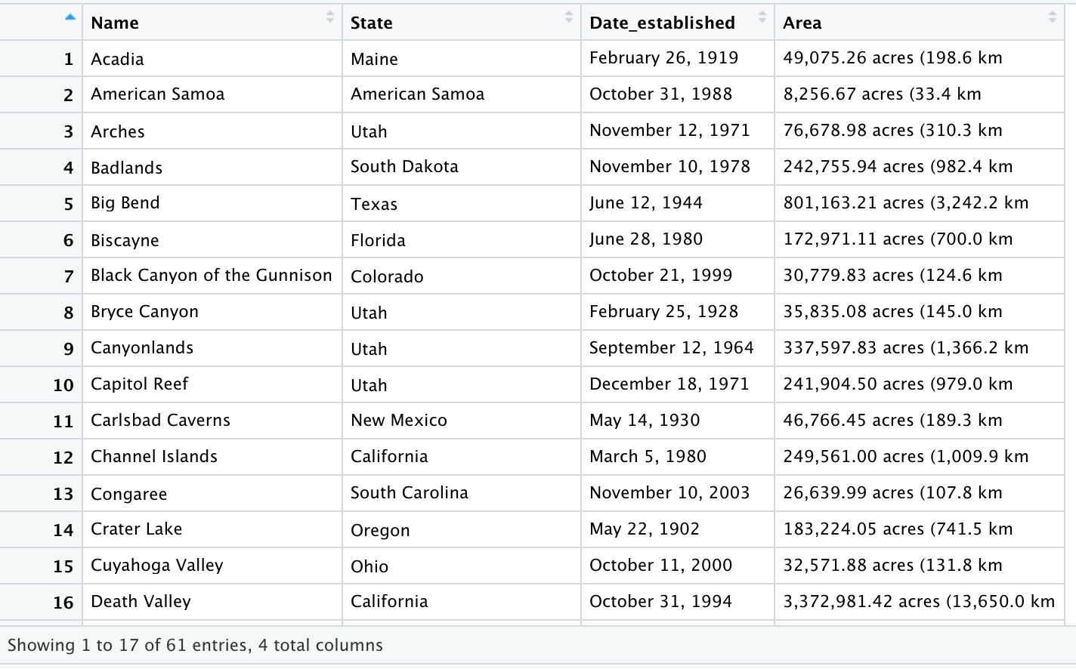**Image 1 –** Figure demonstrates initial view of the “parks” dataframe before the clean up – obtained from (List of National Parks of the United States.)



**Image 2 –** Figure contains the view of the final “clean_parks” dataframe as called from R.



**Image 3 –** Figure demonstrates the peak height for the provided national parks, according this the extracted peak height information. (List of National Parks of the United States.)



**Image 4 –** Dataframe which contains top 10 most visited National Parks in the US in 2018.



**Image5 –** Figure of the dataframe which contains example of future data to be recorded and obtained from all national parks. The dataframe contains the name of the National park, the date of the accident, and the accident description.



**Image 6 -** Counts of Accident Reports over the years in Yosemite



**Image 7 –** Figure of data frame, which contains National Park name, trail name, and the description of the level of difficulty of that trail.



**Image 8 -** Figure contains initial view of the “elevation” dataframe before clean up .



**Image 9 –** Figure contains initial view of the “elev_all_parks” dataframe after the clean up – final version.

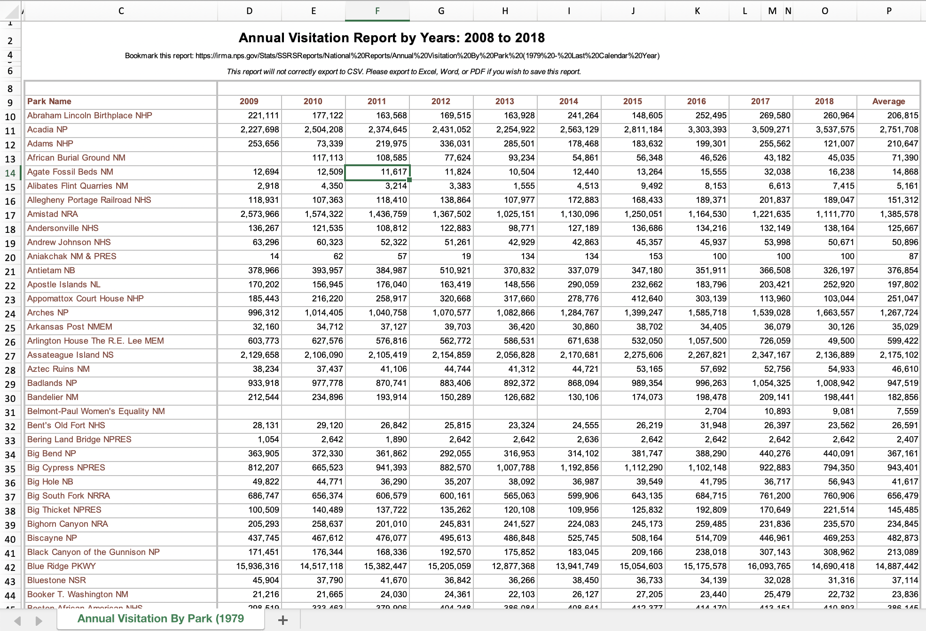

**Image 10 –** Figure contains the view of excel spreadsheet which was obtained form National Park Service. This is the unformatted original view of the obtained data.



**Image 11 –** Figure contains the view of “annual_report” dataframe from R once the data has been appropriately cleaned up.



**Image 12 –** Figure contains the view of a SQL query from R. The query works as a demonstration that the tables were uploaded to the database and can be successfully retrieved.

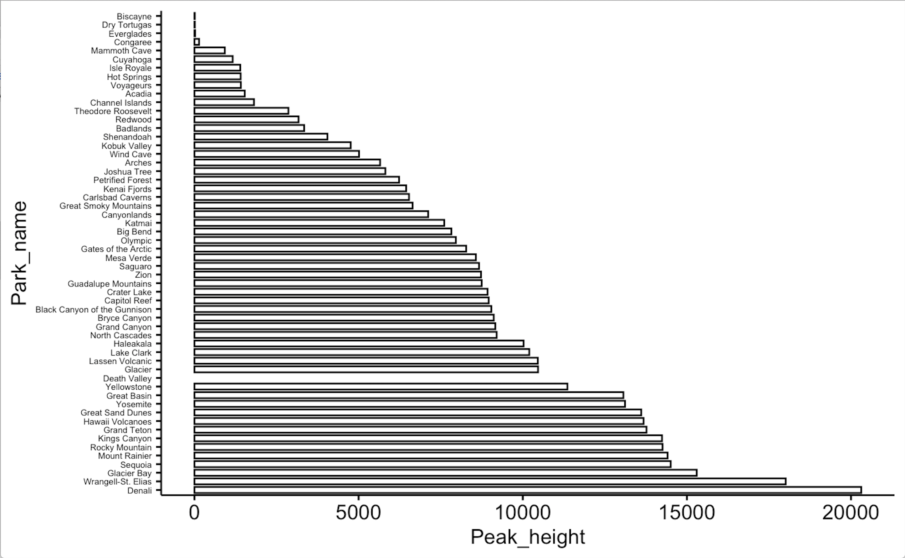

**Image 13 –** Figure illustrates the issue encountered with the formatted data from the open source. This figure demonstrates the presence of NA values for Death Valley in the “elev_all_parks” dataframe. The issue was successfully resolved.

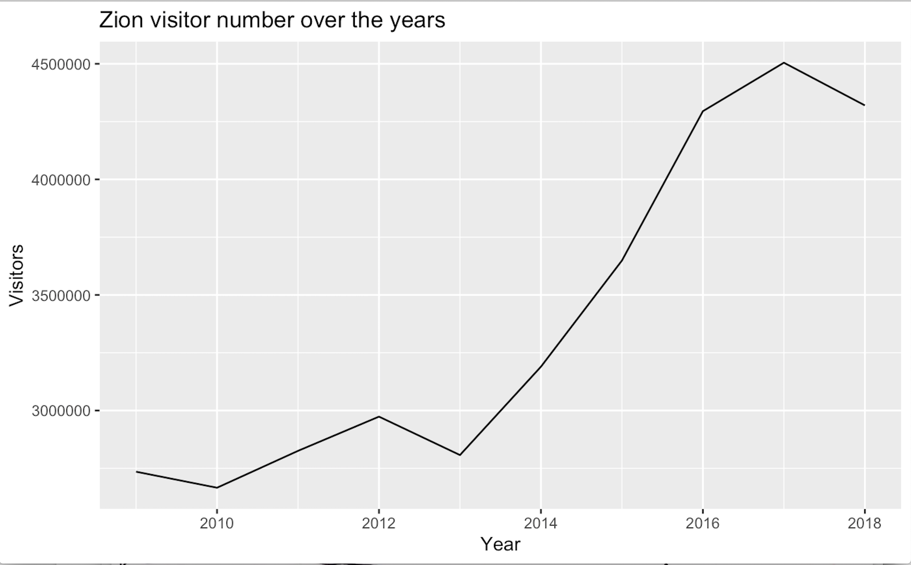

**Image 14 –** Figure demonstrates the change in the visitor number to Zion National Park over the years. This is an example of visualization and analysis that can be done with the extracted data.

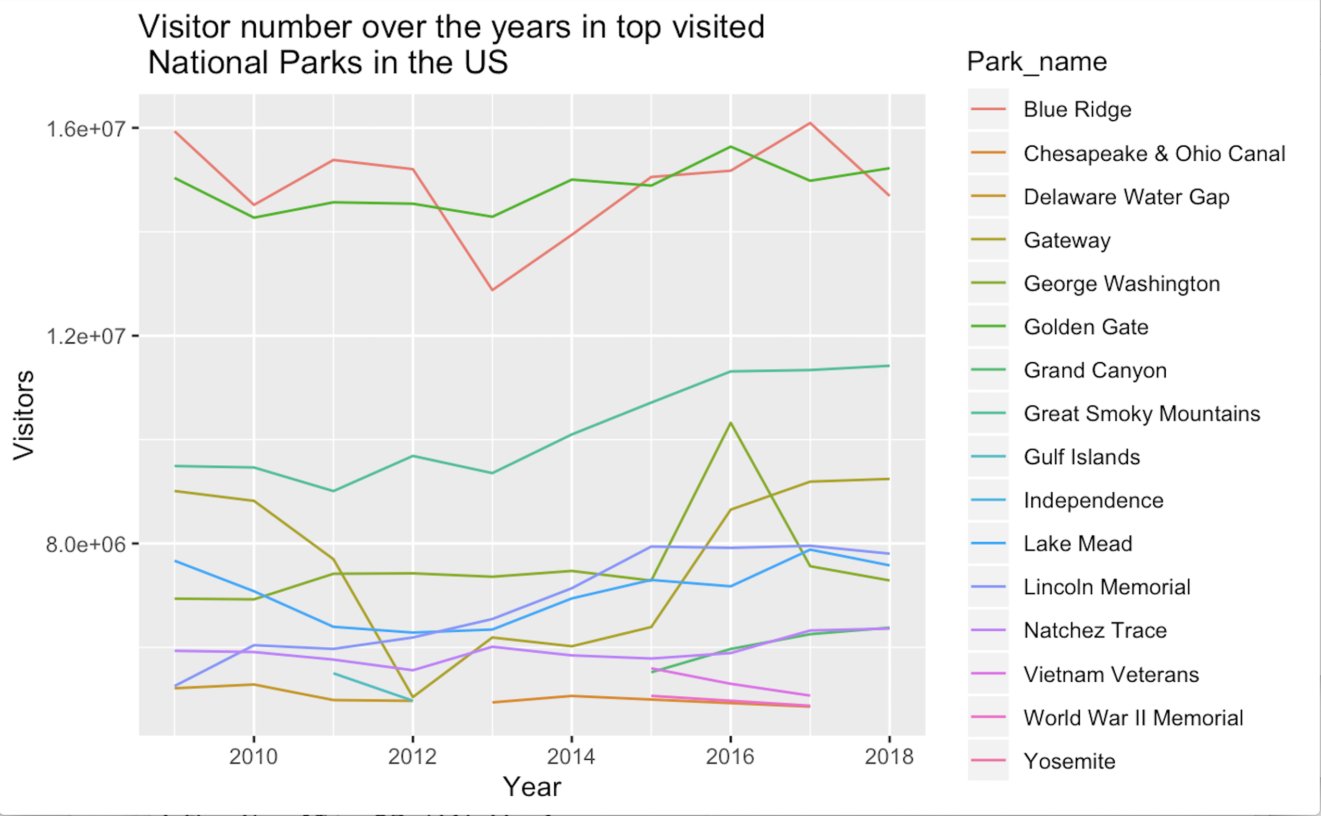

**Image 15 -** Demonstration of the most visited parks over the years, limited sample of data for this example plot.

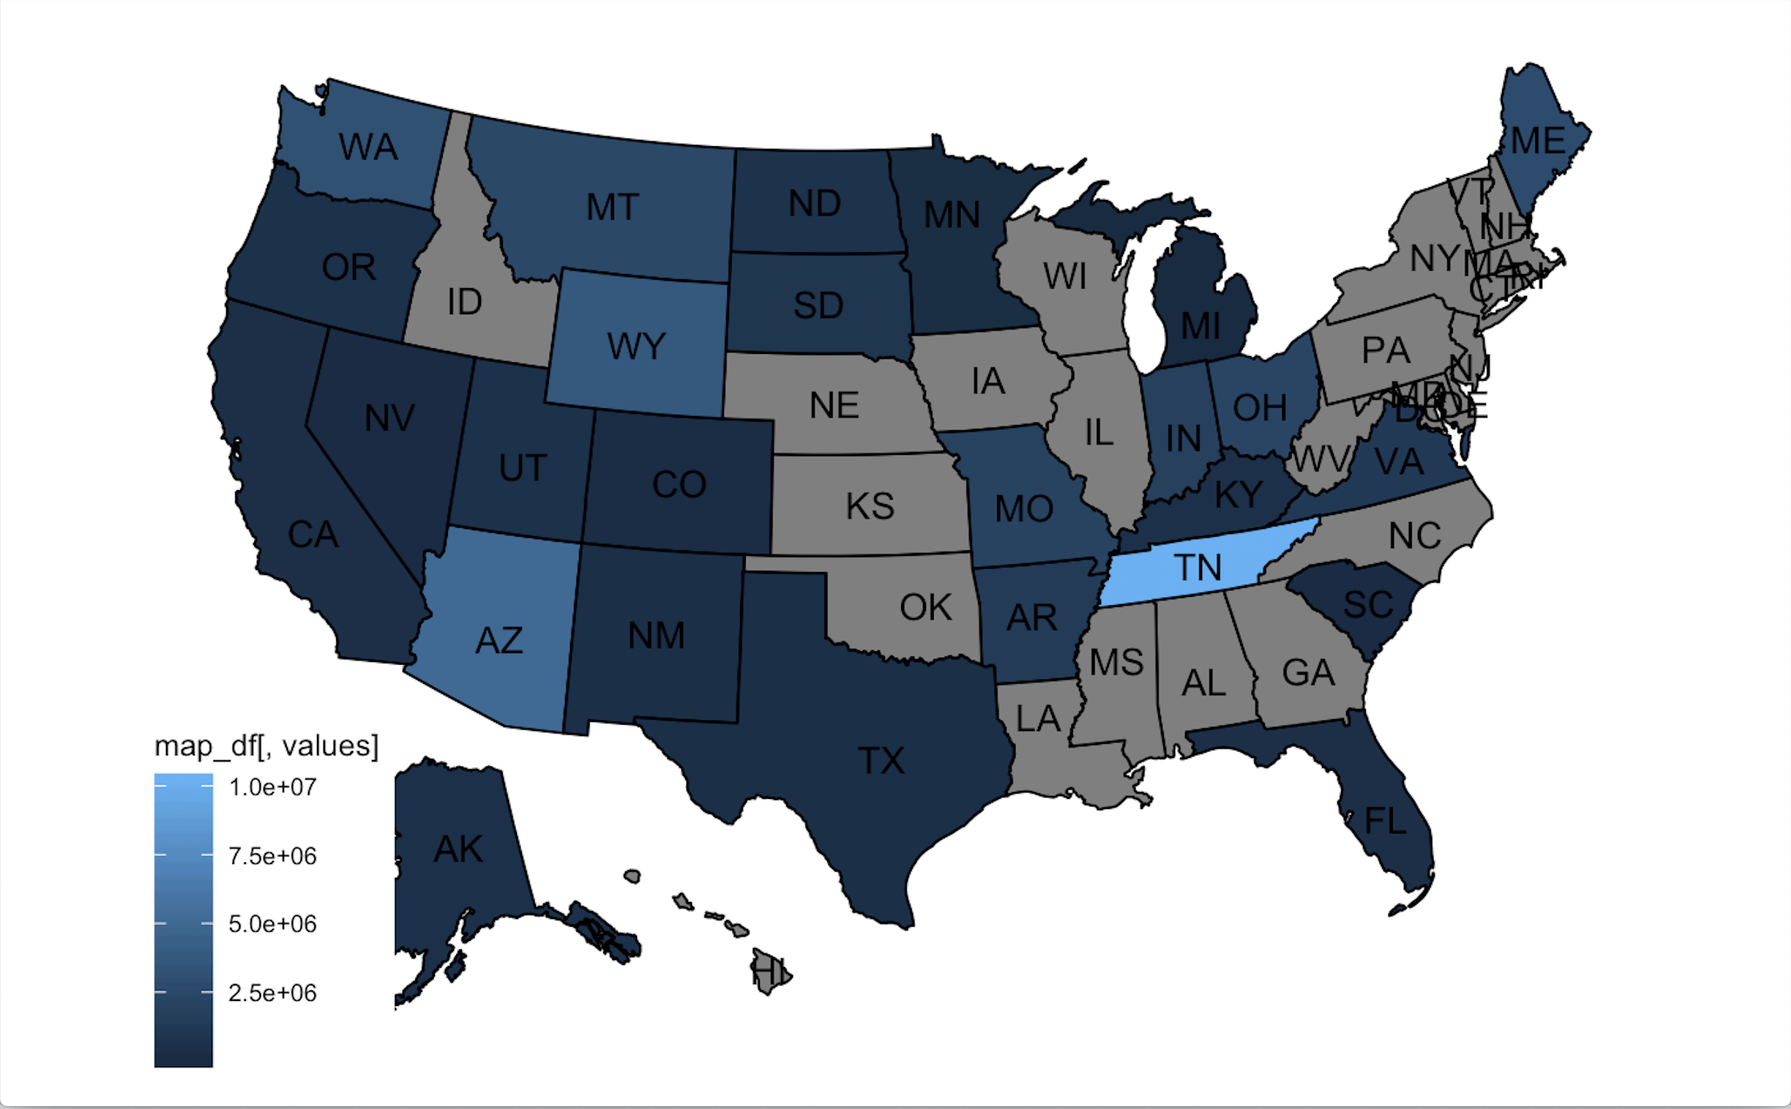

**Image 16 –** Figure depicts the density of available data of average visits to the national parks in the highlighted states (from dark blue to light blue). The average is over 10 year period for the recreational visits for the available national parks.

# Works Cited

*100 Years of Warming in the National Parks*. 25 May 2016. Climate Central. <https://www.climatecentral.org/gallery/graphics/100-years-of-warming-at-the-national-parks>.

*12 Day Hikes in Yellowstone*. 4 June 2019. Yellowstone National Park Lodges. <https://www.yellowstonenationalparklodges.com/connect/yellowstone-hot-spot/trail-mix-12-awesome-day-hikes-in-yellowstone/>.

*List of National Parks of the United States.* n.d. Wikipedia. November 2019. <https://en.wikipedia.org/wiki/List_of_national_parks_of_the_United_States>.

*National Parks Service*. n.d. U.S. Department of the Interior. November 2019. <https://irma.nps.gov/STATS/Reports/Park>.

*News Releases (U.S. National Park Service)*. n.d. National Parks Service. December 2019. <https://www.nps.gov/aboutus/news/news-releases.htm#sort=Date_Released desc&fq[]=Date_Released:[NOW-29DAYS TO NOW]>.

*Olympic National Park Hiking Trails*. n.d. National Parked. <https://www.nationalparked.com/olympic/hiking-trails.>.

*Search and Rescue: Lessons from the Field*. n.d. National Parks Service. <https://www.nps.gov/yose/blogs/psarblog.htm>.

*Stats Report Viewer*. n.d. National Parks Service. November 2019. <https://irma.nps.gov/STATS/SSRSReports/National Reports/Annual Visitation By Park (1979 - Last Calendar Year)>.

*Visitation Numbers (U.S. National Park Service)*. n.d. National Parks Service. <https://www.nps.gov/aboutus/visitation-numbers.htm>.

*Web Data Integration – Import.io - Data Extraction, Web Data Harvesting, Data Preparation, Data Integration*. n.d. Import.io. <https://www.import.io/>.

Wee, Rolando Y. *Oldest National Parks In The United States.* 27 June 2016. WorldAtlas. November 2019. <https://www.worldatlas.com/articles/oldest-national-parks-in-the-united-states.html.>.

*Western U.S. National Parks Popular with Foreign Tourists*. n.d. Visa. <https://usa.visa.com/partner-with-us/visa-consulting-analytics/western-us-national-parks-popular-with-foreign-tourists.html>.

*Yosemite Valley Day Hikes*. n.d. National Parks Service. <https://www.nps.gov/yose/planyourvisit/valleyhikes.htm>.